Psalm 147 vv 1-7 Common Worship Chant: C. V. Stanford

Chant on a single line of music:



Or, on two lines of music for copying into narrow columns:

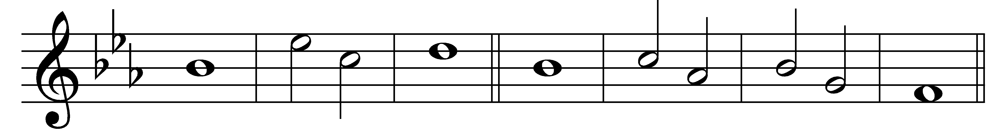

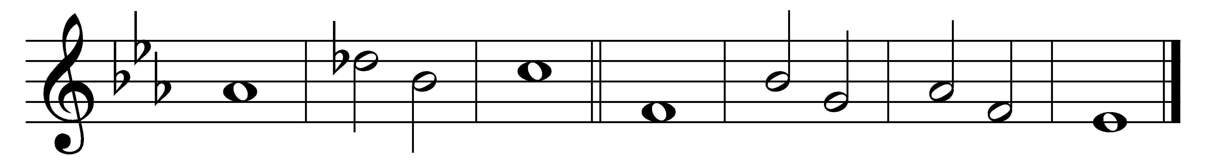

How good it is to make | music· for our | God,

how joyful to | honour | him with | praise.

2 The Lord | builds up· Je- |rusalem

and gathers to- |gether· the | outcasts· of | Israel.

3 He heals the | broken- |hearted

and | binds up | all their | wounds.

4 He counts the |number· of the | stars

and | calls them· all | by their | names.

5 Great is our Lord and | mighty· in | power;

his | wisdom· is be- |yond all | telling.

6 The Lord | lifts up· the | poor,

but casts | down the | wicked· to the | ground.

*2nd part* 7 Sing to the | Lord with | thanksgiving;

make music to our | God up- |on the | lyre.

Words taken from Common Worship © The Archbishops’ Council 2000.